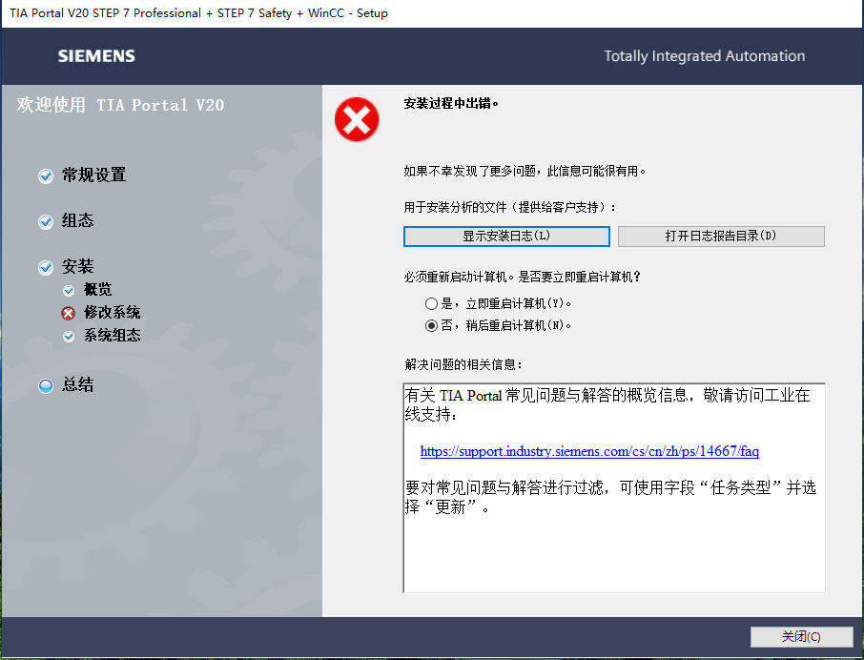

打开“显示安装日志（L）”

2025.10.22 10:47:20 - Year.Month.Day - Log start

BUNDLE: SIMATIC TIA Portal STEP 7 V20 - WinCC V20
SEBU Version: Advanced:TPE.V20000000_RTM.RTM.ERL:V20.00.00.00_95.01.00.01

OS: Microsoft Windows 10 专业版 - Professional, 64-bit, build 19045
COMMANDLINE: C:\Program Files (x86)\Common Files\Siemens\Automation\Siemens Installer Assistant\500\SIA2.exe /starter /bundlepath=F:\InstData
INSTALLDIR: C:\Program Files\Siemens\Automation
SETUPLANGUAGE: 2052
PRODUCTLANGUAGES: 1033;2052

CHANGES: (+)Asp_DotNet_Core_v806;(o)DotNet_Runtime_v806;(o)INSTSQL2022EXP_SCADA;(+)SYMLINK;(+)SYMLINKADD;(+)OPCUALDS;(o)NCMGPRS64;(o)WinCC ACE;(o)WinCC Common Archiving;(o)OPC;(o)SECON;(+)S7PCT;(o)S7EDB;(+)HelpViewer_WebApp_Service;(+)TIA_Portal;(+)TIAP_Shim;(+)MU_Client;(+)HWCN-HWCOL;(+)SUPBASEH02;(+)SUPBASEH03;(+)SUPBASEH04;(+)SUPBASETO01;(+)SUPBASETO02;(+)SUPBASEWCF01;(+)TIAP_SIMATIC;(+)TIAP_SIMATIC32;(+)TIAP_SecAudit;(+)HelpViewer_Server;(+)STEP7;(o)PTSymLib;(o)PTTouchInput;(o)AddinRolloutService;(+)HM_AllEditions;(+)HM_NoBasic;(o)UMC64;(o)UMTRAYICON;(o)AlmPanelPlugin64;(o)Prosave;(+)TIA_ES_BAS;(+)TIA_ES_CA;(+)TIA_ES_Bas32;(+)WinCCUnified_ES;(+)WinCC_Tr_Mandatory;(o)CoRtHmiRTmDriver64;(+)HMIRTMV11;(+)RT_Adv_Sim;(+)TIACOMPCHECK;(+)S7FPLUS;(+)TIA_Opns;(+)OptionVCI;(+)SESSP;(+)ETWEventCollector;(+)TelemetryConnector;(+)TIAAdminV3;(+)TIAAdminV3_TIA;(+)TIAAdminV3_SWM;(+)TIAAdminV3_TIAUMAC;(+)TIAAdminV3_ALM;(o)ProjectServer

There are NO severe messages before the installation

10:47:20 | BEGIN. Execution started.
10:47:22 | OK RunningProcesses () Complete
10:47:23 | OK InventoryBefore (A) Complete
10:47:23 | OK Citamis (Before) Complete
10:47:48 | OK SecurityControlFeature (ReturnFeatures) Complete
10:47:48 | OK StartApplBefore (TIAP20::[INSTALLDIR]BIN\SIEMENS.AUTOMATION.OBJECTFRAME.FILESTORAGE.SERVER.EXEkill)Complete
10:47:48 | OK StartApplBefore (TIAADMINV3::[INSTALLDIR]HOST\AWB\SERVER\DIST\NODE.EXE[INSTALLDIR]host\awb\server\dist\start.js--stop--uninstall--serviceName=SiemensTiaAdminV3--appName=TIAAdminV3)Complete
10:47:48 | OK StartApplBefore (TIAADMINV3::C:\WINDOWS\SYSWOW64\CMD.EXE/ctaskkill/f/IMTiaAdminNotifier.exe/t)Complete
10:47:48 | OK StartApplBefore (TIAP20::[INSTALLDIR]X64\BIN\SIEMENS.AUTOMATION.OBJECTFRAME.FILESTORAGE.SERVER.EXEkill)Complete
10:47:48 | OK ClassicCompPrepare () Complete
10:47:48 | OK ProductRegistration (Before) Complete
10:47:48 | OK ClassicCompAfterUninstall () Complete
10:47:52 | OK SetupUnit (Asp_DotNet_Core_v806) Complete Foreign AddLocal
10:47:55 | OK SetupUnit (DotNet_Runtime_v806) Complete Foreign Reinstall
10:47:55 | OK Checkpoint (RE) Complete
10:47:57 | OK SetupUnit (INSTSQL2022EXP_SCADA) Complete ClassicProductReinstall
10:47:57 | OK Checkpoint (E) Complete
10:47:57 | OK SetupUnit (SYMLINK) Complete Foreign AddLocal
10:47:57 | OK SetupUnit (SYMLINKADD) Complete Foreign AddLocal
10:48:07 | OK SetupUnit (OPCUALDS) Complete Foreign AddLocal
10:48:24 | OK SetupUnit (NCMGPRS64) Complete ClassicComponentReinstall
10:48:25 | OK SecurityControl (WinCC ACE) Complete
10:49:53 | OK SetupUnit (WinCC ACE) Complete ClassicComponentReinstall
10:49:57 | OK SecurityControl (WinCC ACE) Complete
10:51:04 | OK SetupUnit (WinCC Common Archiving) Complete ClassicComponentReinstall
10:51:16 | OK SetupUnit (OPC) Complete ClassicComponentReinstall
10:51:28 | OK SetupUnit (SECON) Complete ClassicComponentReinstall
10:51:28 | OK SecurityControl (S7PCT) Complete
10:53:32 | OKRebootAfterAll SetupUnit (S7PCT) Complete PlusMain AddLocal
10:53:34 | OK SecurityControl (S7PCT) Complete
10:53:49 | OK SetupUnit (S7EDB) Complete ClassicComponentReinstall
10:53:58 | OK SetupUnit (HelpViewer_WebApp_Service) Complete PlusMain AddLocal
10:53:59 | OK SecurityControl (TIA_Portal) Complete
10:54:50 | OK SetupUnit (TIA_Portal) Complete PlusMain AddLocal
10:54:50 | OK SecurityControl (TIA_Portal) Complete
10:55:04 | OK SetupUnit (TIAP_Shim) Complete PlusOptionalAddLocal
10:55:11 | OK SetupUnit (MU_Client) Complete PlusOptionalAddLocal
10:55:18 | OK SetupUnit (HWCN-HWCOL) Complete PlusOptionalAddLocal
10:55:30 | OK SetupUnit (SUPBASEH02) Complete PlusOptionalAddLocal
10:55:39 | OK SetupUnit (SUPBASEH03) Complete PlusOptionalAddLocal
10:55:46 | OK SetupUnit (SUPBASEH04) Complete PlusOptionalAddLocal
10:55:53 | OK SetupUnit (SUPBASETO01) Complete PlusOptionalAddLocal
10:56:06 | OK SetupUnit (SUPBASETO02) Complete PlusOptionalAddLocal
10:56:14 | OK SetupUnit (SUPBASEWCF01) Complete PlusOptionalAddLocal
10:56:28 | OK SetupUnit (TIAP_SIMATIC) Complete PlusOptionalAddLocal
10:56:40 | OK SetupUnit (TIAP_SIMATIC32) Complete PlusOptionalAddLocal
10:56:47 | OK SetupUnit (TIAP_SecAudit) Complete PlusOptionalAddLocal
10:56:57 | OK SetupUnit (HelpViewer_Server) Complete PlusOptionalAddLocal
10:58:32 | OK SetupUnit (STEP7) Complete PlusOptionalAddLocal
10:59:06 | OK SetupUnit (PTSymLib) Complete ClassicComponentReinstall
10:59:19 | OK SetupUnit (PTTouchInput) Complete ClassicComponentReinstall
10:59:33 | OK SetupUnit (AddinRolloutService) Complete ClassicComponentReinstall
11:01:00 | OK SetupUnit (HM_AllEditions) Complete PlusOptionalAddLocal
11:02:09 | OK SetupUnit (HM_NoBasic) Complete PlusOptionalAddLocal
11:02:10 | OK SecurityControl (UMC64) Complete
11:03:52 | OK SetupUnit (UMC64) Complete PlusMain Reinstall
11:03:54 |ERROR SeconWorker::ExecuteSeconWork(): - Secon call has been finished with errors
11:03:54 | FAIL! SecurityControl (UMC64) Failed
11:04:04 | OK SetupUnit (UMTRAYICON) Complete PlusOptionalReinstall
11:10:17 | OK SetupUnit (AlmPanelPlugin64) Complete ClassicComponentReinstall
11:11:31 | OKRebootAfterAll SetupUnit (Prosave) Complete ClassicProductReinstall
11:14:18 | OK SetupUnit (TIA_ES_BAS) Complete PlusOptionalAddLocal
11:14:43 | OK SetupUnit (TIA_ES_CA) Complete PlusOptionalAddLocal
11:14:50 | OK SetupUnit (TIA_ES_Bas32) Complete PlusOptionalAddLocal
11:15:10 | OK SetupUnit (WinCCUnified_ES) Complete PlusOptionalAddLocal
11:15:45 | OK SetupUnit (WinCC_Tr_Mandatory) Complete PlusOptionalAddLocal
11:16:09 | OK SetupUnit (CoRtHmiRTmDriver64) Complete ClassicComponentReinstall
11:16:09 | OK SecurityControl (HMIRTMV11) Complete
11:16:30 | OKRebootAfterAll SetupUnit (HMIRTMV11) Complete PlusMain AddLocal
11:16:32 | OK SecurityControl (HMIRTMV11) Complete
11:16:37 | OK SetupUnit (RT_Adv_Sim) Complete PlusOptionalAddLocal
11:16:46 | OK SetupUnit (TIACOMPCHECK) Complete PlusOptionalAddLocal
11:16:58 | OK SetupUnit (S7FPLUS) Complete PlusOptionalAddLocal
11:16:58 | OK SecurityControl (TIA_Opns) Complete
11:17:14 | OK SetupUnit (TIA_Opns) Complete PlusOptionalAddLocal
11:17:14 | OK SecurityControl (TIA_Opns) Complete
11:17:24 | OK SetupUnit (OptionVCI) Complete PlusOptionalAddLocal
11:18:12 | OK SetupUnit (SESSP) Complete PlusOptionalAddLocal
11:18:27 | OK SetupUnit (ETWEventCollector) Complete ClassicComponentAddLocal
11:18:35 | OK SetupUnit (TelemetryConnector) Complete ClassicComponentAddLocal
11:19:23 | OK SetupUnit (TIAAdminV3) Complete PlusMain AddLocal
11:19:36 | OK SetupUnit (TIAAdminV3_TIA) Complete PlusOptionalAddLocal
11:20:03 | OK SetupUnit (TIAAdminV3_SWM) Complete PlusOptionalAddLocal
11:20:17 | OK SetupUnit (TIAAdminV3_TIAUMAC) Complete PlusOptionalAddLocal
11:20:26 | OK SetupUnit (TIAAdminV3_ALM) Complete PlusOptionalAddLocal
11:20:44 | OK SetupUnit (ProjectServer) Complete PlusMain Reinstall
11:20:44 | OK ClassicCompAfterInstall () Complete
11:20:44 | OK ClassicCompRollback () Complete
11:20:44 | OK HspInstall () Complete
11:20:44 | OK MspInstall () Complete
11:20:44 | OK StartApplAfter (TIAP20::[INSTALLDIR]BIN\INSTALLROOTCERTIFICATE.EXE-fCertificateList.ini-lC:\ProgramData\Siemens\Automation\Logfiles\Setup\InstallRootCertificate.log)Complete
11:20:46 | OK StartApplAfter (TIAADMINV3::[INSTALLDIR]HOST\AWB\SERVER\DIST\NODE.EXE[INSTALLDIR]host\awb\server\dist\start.js--install--start--serviceName=SiemensTiaAdminV3--serviceDisplayName=TIA Administrator V3--appName=TIAAdminV3--port=8900--appDisplayName=TIA Administrator)Complete
11:20:47 | OK StartApplAfter (TIAADMINV3::TIAADMINNOTIFIER.EXE-i)Complete
11:30:35 | OK StartApplAfter (TIAP20::[INSTALLDIR]BIN\SIEMENS.AUTOMATION.GENERATOR.FRAMEWORK.EXEMODIFIEDC:\ProgramData\Siemens\Automation\Logfiles\Setup\)Complete
11:30:35 | SKIP! StartApplAfter (TIAADMINV3::C:\WINDOWS\SYSWOW64\CMD.EXE/creg add HKEY_LOCAL_MACHINE\SOFTWARE\Siemens\AUTSW\Global /reg:32 -v EnableCheckForUpdates /d Disable /f)Skip
11:30:35 | OK StartApplAfter (TIAP20::C:\WINDOWS\SYSWOW64\S7EPATSX.EXE-silent-force)Complete
11:30:36 | OK StartApplAfter (S7PCT::C:\WINDOWS\SYSWOW64\S7EPATSX.EXE/Silent)Complete
11:30:37 | OK StartApplAfter (TIAP20::C:\WINDOWS\SYSWOW64\S7EPAESX.EXE-silent-force)Complete
11:30:38 | OK StartApplAfter (TIAP20::[INSTALLDIR]BIN\SIEMENS.SIMATIC.HWCN.INTERPRETER.IG.GSD.GENERATOR.EXE-g-lC:\ProgramData\Siemens\Automation\Logfiles\Setup\gsd.log)Complete
11:30:47 | OK ProductRegistration (After) Complete
11:30:48 | OK SetupIsComplete () Complete
11:30:49 | OK InventoryAfter (Z) Complete
11:30:50 | OK LicenseTransfer (False) Complete
11:30:50 | OK Citamis (After) Complete
11:30:50 | OK SetupSummary () Complete
11:31:39 | OK SetupReport () Complete
11:31:39 | END. Execution completed.

Intermediate ExitCode after execution queue : 1603 - Exit code means: Installation failed (InstallFailure)
Errors: 1
Warnings: 0

